Class test 3

Find the shear force and bending moment at the supports for the beam carrying the load shown below.

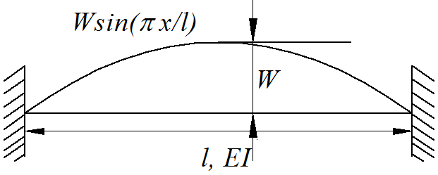 (5)

Use the moment distribution method to solve the problem below.

Draw the shear force and the bending moment diagrams.

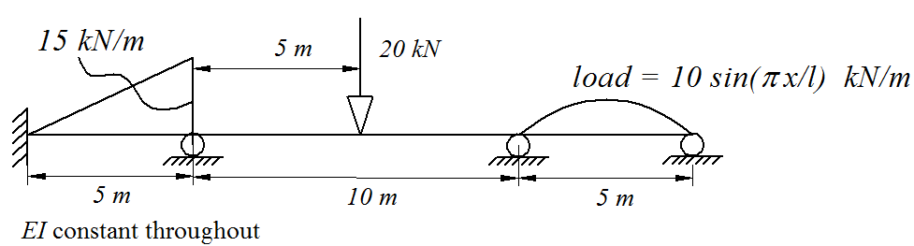

(15)